**Abstract:**

The experiment is about the determination of the characteristic curve of a diode. The objective of this experiment is to become familiar with semiconductor diode and determine its characteristic curve. The volt – ampere (I-V) characteristics of a diode give the variation of diode current with the voltage. This characteristic curve is essential to understand the behavior of a diode when it is connected to circuit. We can understand the behavior of a diode when it is connected to a circuit by analyzing the characteristic curve.

**Introduction:**

The objectives of this experiment are,

1. To become familiar with semiconductor diode.
2. To determine the characteristic curve of a semiconductor diode.

**Theoretical Background:**

**Diode Structure**

The semiconductor diode is created by simply joining an n-type and a p-type material together [1]. It is a pn junction as shown in Figure 1. As indicated, the pn junction consists of p-type semiconductor material in contact with n-type semiconductor material. A variety of semiconductor materials can be used to form pn junctions like silicon, germanium, gallium arsenide etc. However, we will concentrate on silicon, as this is the most widely used material in microelectronics. In actual practice, both the p and n regions are part of the same silicon crystal. The pn junction is formed by creating regions of different doping (p and n regions) within a single piece of silicon. The material is doped by bringing in additional atoms (impurities). The impurities can be either donors or acceptors atoms. The words acceptor and donor can be associated with donating and accepting electrons.



**Figure 1: pn junction diode structure**



**Figure 2: a) separate pieces b) pn junction**

**PN Junction**

To understand how a pn junction is formed we will start by imagining two separate pieces of semiconductor, one n-type and the other p-type as shown in Figure 2(a). Now we bring the two pieces together to make one piece of semiconductor. This results in the formation of a pn junction (Figure 2(b)).

**Forward/Reverse Bias Characteristics**

If a negative voltage is applied to the pn junction, the diode is in reverse biased. In response, free holes and electrons are pulled towards the end of the crystal and away from the junction. The result is that all available carriers are attracted away from the junction, and the depletion region is extended. There is no current flow through under such conditions. If the applied voltage is positive, the diode operates in forward bias. This has the effect of shrinking the depletion region. Now, electrons in the p-type end are attracted to the positive applied voltage, while holes in the n-type end are attracted to the negative applied voltage.

**Diode Characteristics**

In forward bias condition, a cut-in voltage has to be overcome for the diode to start conduction. In silicon, this voltage is about 0.7 volts. In reverse-bias condition, the current is limited to IS (reverse saturation current). For higher value of reverse voltages, the junction breaks down. Figure 3 shows the diode I-V characteristics.



**Figure 3: Diode IV Characteristics**

**Apparatus:**

|  |  |  |
| --- | --- | --- |
| **No.** | **Apparatus** | **Quantity** |
| 1 | Diode | 1 |
| 2 | 10 K Resistance | 1 |
| 3 | Project Board | 1 |
| 4 | DC Power Supply | 1 |
| 5 | Multimeter | 1 |

**Circuit Diagram:**

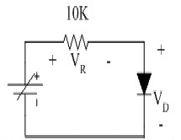

Figure 4: Circuit diagram for determining diode characteristic

**Safety Precaution:** The following is a list of some of the special safety precautions that were taken into consideration while working with diode:

1. A diode into a circuit with voltage applied was never removed or inserted.
2. While testing a diode, we ensured that the test voltage does not exceed the diode’s maximum allowable voltage.
3. A replacement diode into a circuit is in the correct direction was ensured.

**Experimental Procedure:**

1. We measured the actual of the 10K resistor and that was 9.86.
2. The components except the power supply as shown in the figure were connected.
3. The DC power supply and measured the voltage across its two terminals was turned on and fixed it at 0V. After that the power supply was turned off.
4. Then we connected the power supply in the circuit and turned it on. Before powering up, the power control knob was at minimum position.
5. We varied the supply voltage in a 0.5V step and measured the voltage across the Diode VD and the voltage across the resistor and record the result in the table for both forward and reverse bias.

|  |  |  |  |
| --- | --- | --- | --- |
| **Vin** | **VD** | **VR** | **Id = VR/(R)** |
| 0.2 | 0.2 | 0 | 0 |
| 0.4 | 0.3 | 0 | 0 |
| 0.52 | 0.42 | 0.1 | 0.01 |
| 0.77 | 0.47 | 0.3 | 0.03 |
| 0.89 | 0.49 | 0.4 | 0.04 |
| 1.01 | 0.51 | 0.5 | 0.05 |
| 1.14 | 0.52 | 0.62 | 0.062 |
| 1.6 | 0.55 | 1.05 | 0.105 |
| 1.81 | 0.56 | 1.25 | 0.125 |
| 2.31 | 0.59 | 1.72 | 0.172 |

**Table 1: Data Table for Diode characteristic (Forward):**

**Table 2: Data Table for Diode characteristic (Reverse):**

|  |  |  |  |
| --- | --- | --- | --- |
| **Vin** | **VD** | **VR** | **Id = VR/(R)** |
| 0.13 | 0.13 | 0 | 0 |
| 0.217 | 0.217 | 0 | 0 |
| 0.397 | 0.397 | 0 | 0 |
| 0.447 | 0.447 | 0 | 0 |
| 0.705 | 0.705 | 0 | 0 |
| 0.915 | 0.915 | 0 | 0 |
| 1.179 | 1.179 | 0 | 0 |
| 1.36 | 1.36 | 0 | 0 |
| 1.59 | 1.59 | 0 | 0 |
| 1.83 | 1.83 | 0 | 0 |

1. Id was calculated and filled up the tables above.
2. VD vs Id characteristic curve for the diode were plotted for both forward and reverse bias.
3. The “knee voltage” was determined.

**Report:**

1. *VD - Id* characteristic curves for the diode:

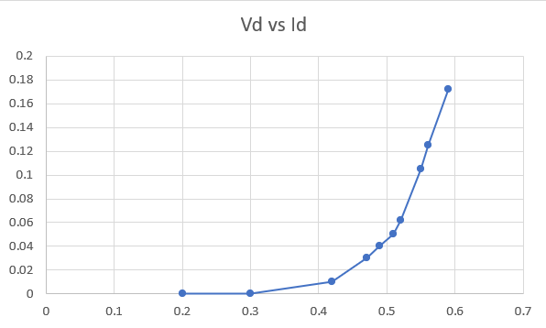

2. If the supply voltage polarity is reversed for the case of using a diode with PIV of 4.8V, it will break down.

3. The characteristic curve of a junction diode is also called I-V Curve. It is typically a graph showing the current flow at different voltages. The current is typically on the y-axis and the voltage on the x-axis. The type of graph provides engineers with a visual record of the operating characteristics of component. This information enables them to use the component more appropriately within a circuit. Si diode Improved temperature sensitivity and easily available. Electronic devices became more sensitive to “Speed” issues.

The result is matched with theoretical value. As noted on the curves the knee of curve is about 0.7 V for this diode.  
  
From the data table for diode characteristic and the characteristic curve, it has been proved that our experimental result has matched with the theoretical result.

**References:**

1. Robert L. Boylestad, Louis Nashelsky, Electronic Devices and Circuit Theory, Ninth Edition, 2007-2008
2. Adel S. Sedra, Kennth C. Smith, Microelectronic Circuits, Saunders College Publishing, 3rd ed., ISBN: 0-03-051648-X, 1991.
3. American International University–Bangladesh (AIUB) Electronic Devices Lab Manual.
4. David J. Comer, Donald T. Comer, Fundamentals of Electronic Circuit Design,

john Wiley & Sons Canada, Ltd.; ISBN: 0471410160, 2002.